 

Q1:

Software Requirements Specification for

Bird Boarding Booking System (BBBS)

Version 1.0 approved

Prepared by

Ha Van Phuoc, ID: SE171793

FU Xavalo ( Ho Chi Minh )

4/2/2024

Q2:

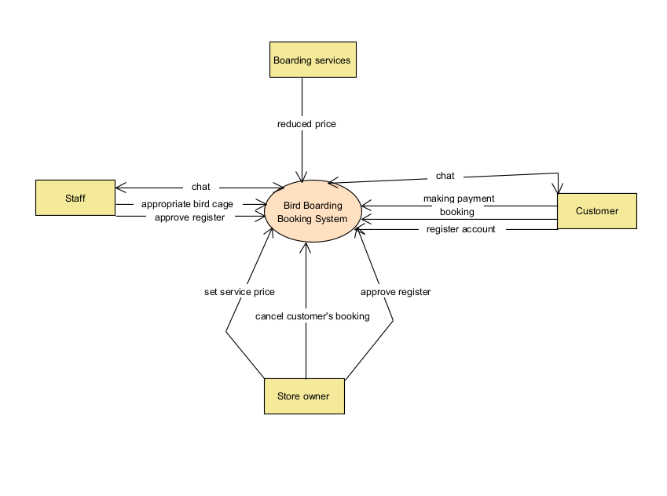

Q3:

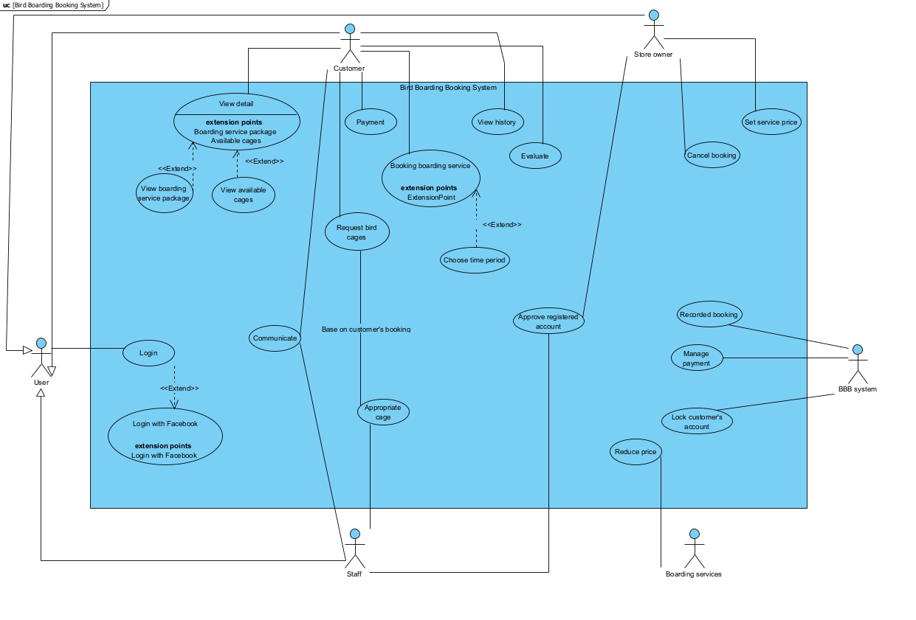

|  |  |  |
| --- | --- | --- |
| **#** | **Actor** | **Description** |
| 01 | Customer | The actor using the system to booking bird boarding services at the store during busy periods |
| 02 | Staff | The actor using the system to communicate with customer and appropriate cage for customer and manage customer login |
| 03 | Store owner | The actor use the system to approve login account ,cancel booking and set the price for boarding service |
| 04 | Boarding service | Reduce price based on store policy |

|  |  |  |  |
| --- | --- | --- | --- |
| **#** | **Use Case** | **Actors** | **Description** |
| UC-01 | Booking a boarding service | Customer | Customer can booking a boarding service |
| UC-02 | Appropriate cage | Staff | Staff appropriate cage when customer does not specify request a bird cage |
| UC-03 | Cancel booking | Store owner | Only store owner has the right to cancel customer’s booking |
| UC-04 | Login | Customer | Customer can login by google or registered account |

Q4:

|  |  |  |
| --- | --- | --- |
| ID | Rule Definition | Use cases |
| BR-01 | In case the customer cancels bookings before the time period set up in the system by store owner, the customer will lose 50% of the amount paid | UC-01, UC-02 |
| BR-02 | The system shall lock a customer account’s after five consecutive unsuccessful login attempts within a period of four minutes | UC-04 |
| BR-03 | A cage contains only birds that belong to one customer |  |
| BR-04 | The price will reduced by 50% for each additional bird added to the cage |  |
| BR-05 | The application must use Microsoft .NET framework 4.8 |  |
|  |  |  |

**Q5:**

1. **The system should have Efficiency**

**When customer login, they will waiting for store owners for approve so that the system needs to response in 4 seconds**

1. **The system should have Confidentiality**

**When customer making payment, the system can save their card information when they allow**